* **Activity 12:**

Deleting a Row from a Table

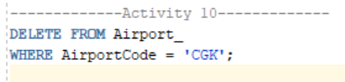

OUTPUT: